**Effective Knowledge Management: From Article Creation to Approval**

**Project Overview**

This project focuses on streamlining the efficient creation  and approval for a comprehensive Knowledge Article within the ServiceNow platform ensuring that the information is accurate, accessible, and beneficial for users seeking solutions or guidance. The project works toward reducing the support ticket volumes by providing readily available, high quality documentation.

**Objectives**

**Business Goals:**

* Make it easier for users to get approval for knowledge articles.
* Saving time and effort from both users and management.
* Taking responsibility for knowledge articles

**Specific Goals:**

* Build a streamlined approval process.
* Hierarchical structuring to ensure approval from authority.
* Providing valid information through articles by approval.

**Key Concepts Used**

* Service Now Administration
* Knowledge base management
* Creation of knowledge article
* Approval of knowledge article

**Detailed Implementation**

**Activity 1: Create A User**

I have created a new user(Jai Prakash) in the IT department with the title of Manager.

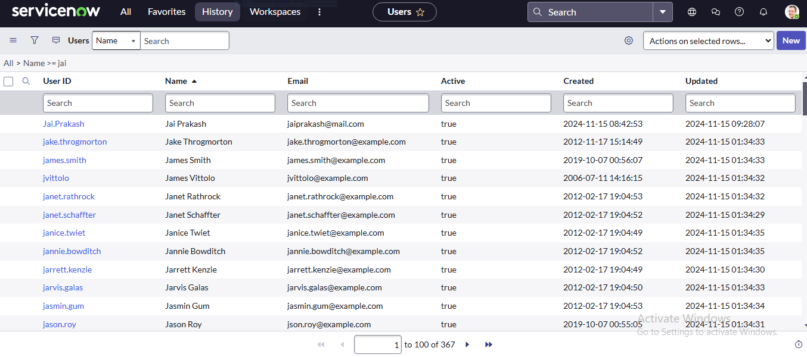

**Activity 2: Create A Group**

Created a manager group to group access permissions and assign managers of the organization some common roles. Added Jai Prakash as a group member in the manager group.

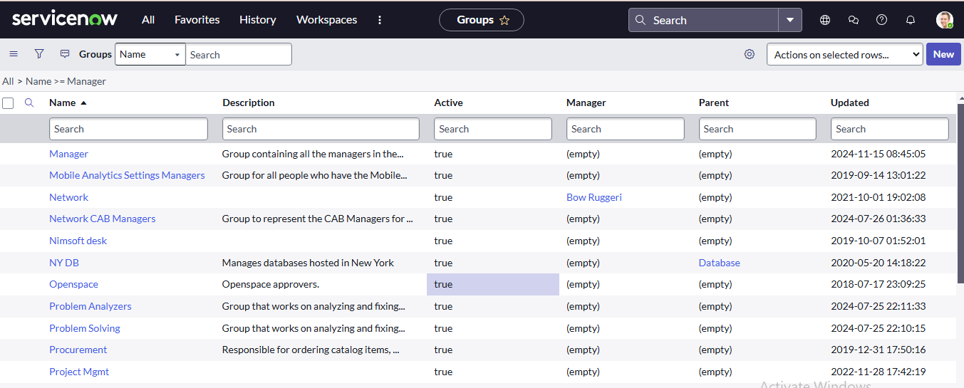

**Activity 3: Create A Role**

Created a new role for Manager under roles in system security.

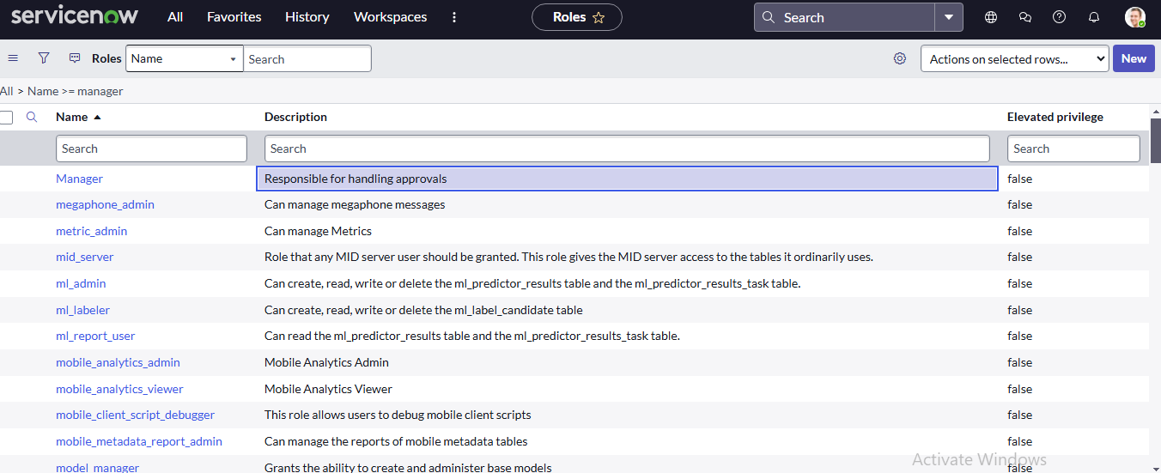

**Activity 4: Changing The Knowledge Base Owner**

Opened knowledge base and selected IT knowledge base and changed the owner from Bernard Laboy to Jai Prakash.

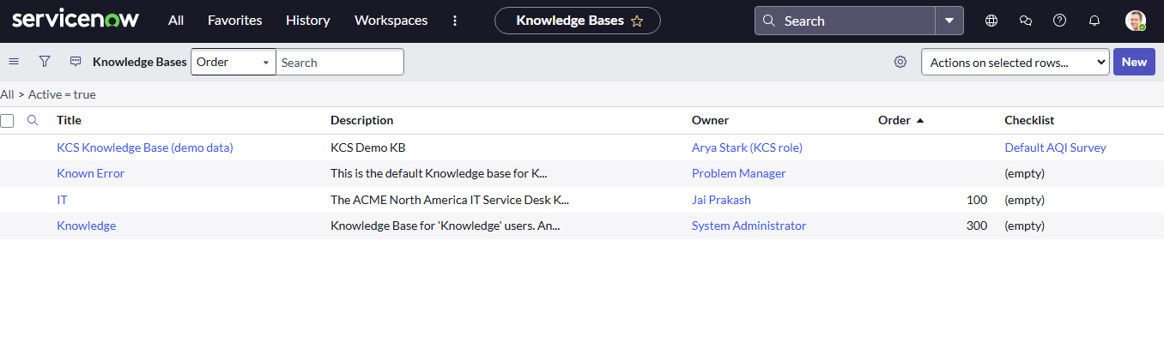

**Activity 5: Knowledge Article Creation**

Created a new knowledge article in the IT knowledge base with the title Cloud Computing and category security. Curated content to add in the article and used it in the article body. Submitted and published the article.

On opening the knowledge article again I confirmed that the knowledge article has been successfully created and assigned for approval.

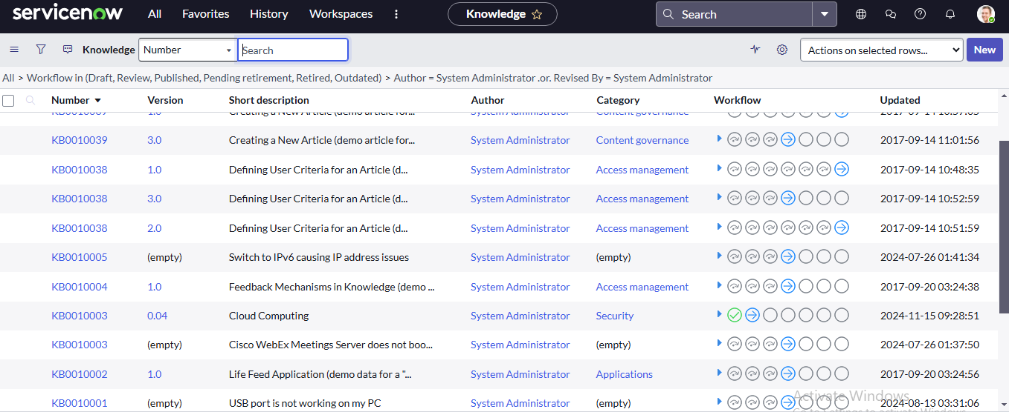

**Result:**

An email has successfully been sent to Jai Prakash(Manager and owner of IT knowledge base) and the article is waiting for approval.

